Lessons from GP-Dallas
Gary Wise
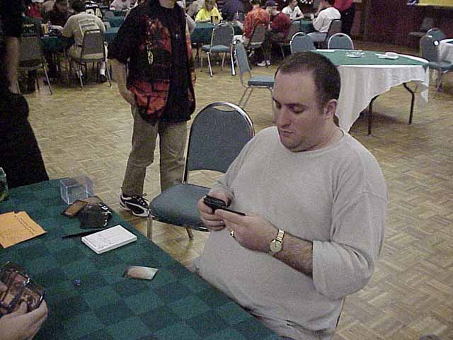
I decided I'd make the trip to GP Dallas before I attended New York. Rochester Draft is my favorite format of all time, so, with Dallas being my first real opportunity in over a year to do some Rochester Drafting at a professional level, I knew that I'd be going, especially with my position in the Masters Series in doubt up until New York.
After New York, with my position in the Masters solidified, I started asking myself why I was bothering with the Dallas trip. The PT points seemed negligible, the money was minor considering the expense of the trip and I could use the time for work, as I'd be leaving for Sydney soon thereafter. Then I arrived in Dallas.
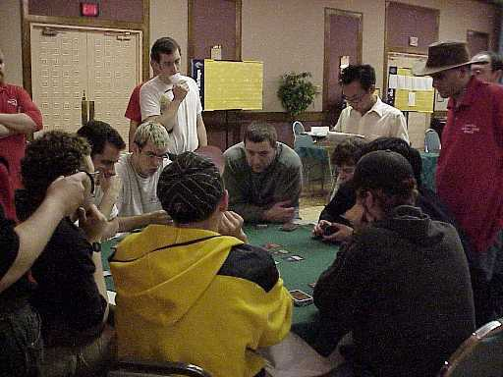
Over the weekend, it was amazing to observe my understanding of the Invasion draft format expand and evolve as I picked up new information and new ideas. While I'd done more then my share of practicing and knew which cards were better then others, I really didn't feel I'd maximized my understanding of the format. With there being no 100% correct answers for draft, I don't ever feel I've ever done so, but getting together with some of the best drafters on this side of the ocean definitely brought me closer to that impossible goal.
This special addition to my series on Invasion will take a look back at what I've written so far, correct a few mistakes on my part and will add to already established ideas. In other words, I'm fallible, but I'm going to doing everything possible to cover my tracks. Hopefully, this will help both you and I to improve our respective draft games. Enjoy.

The Rule
I agree with a lot of what Zvi Mowshowitz said about having a rule to draft by. It's important to go into a draft with an idea of what you want to do once you start checking out the packs, because such pre-dispositions allow you a certain degree of organization from the beginning, and this can result in the utilization of all forty five cards you draft, while those without a plan will often waste a couple of picks.
Where Zvi and I differ is what the rule for this particular environment is. When formulating a draft plan, there is no right or wrong, as each individual's Rule will apply to him or her alone. One's rule must adhere to one's style of play, and as my style is apparently a little more aggressive then Zvi's, the Rule I adhere to when going into a draft is to draft UB.
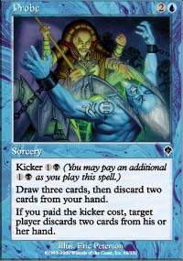
This isn't an unusual or creative approach. It was apparent in Dallas that UB was the dominant archetype, to the extent that players were formulating ideas about what the best way to beat the deck was. In both drafts I did in the tourney, the consensus seemed to be that mine were the best decks at their respective tables, and in both instances I started out drafting UB, merely taking the best spells available in that color combo.
What is it that makes the BU deck so strong? Superior spells. With cards like Repulse, Exclude, Recoil and Probe, the deck is capable of garnering incredible card advantage, and those are only the commons. Throw in cards like Fact or Fiction and things get ludicrous. BU also has the most efficient kill spells in the format, like Agonizing Demise, Spite/Malice and Exotic Curse, and the largest common evasion creatures in the format in the form of Duskwalker and Faerie Squadron. In the end, it comes down to this: Through sheer card advantage, this deck can trade cards until it has achieved table parity while holding five cards in hand to an opponent's two. This means that the longer the game goes, the better it is for UB.

Three Color Drafting
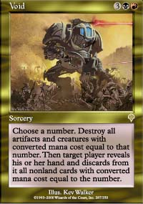
There is not a common in the set that requires two mana of any one color to cast
I think it's pretty obvious that Invasion has been set up in a way that allows for the drafting of more than two colors. The combination of mana diversity cards (Harrow, Fertile Ground, Dream Thrush) and multi-color bombs should be enough incentive to go three colors, but one thing I didn't realize was that the entire set was designed with three color drafting in mind.
If one was to go through the common sequences of the set, one would eventually realize just how easy it is to integrate an abnormal number of colors into their draft decks thanks in part to how easy Invasion's commons are to cast. While cards like Faerie Squadron and Pouncing Kavu require two colored mana to be used to their full potential, there is not a common in the set that requires two mana of any one color to cast.
What this means is that splashing 5-6 cards, instead of the 1-2 of the past, is possible, as your splash cards will never require more than one mana of the required splash-color's mana. In other words, don't look to go three colors, but if the opportunity to get a neighboring power card is there, you should definitely consider taking it an option.

GW
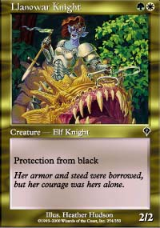
In discussions concerning how best to beat the UB archetype, the consensus seemed to be an aggressive GW deck with as much Protection from Black as possible. When I lost my final match of the swiss, it was to a deck that never played a non- protection from Black creature. This rendered such cards as Barrin's Spite, Agonizing Demise and Recoil useless, leaving me incapable of outracing my opponent and his Armadillo Cloak.
This deck is the hardest for UB to beat because of the combination of protection from black creatures and aggression. From the word go, this deck is racing, but at the same time, with cards like Crimson Acolyte and Dismantling Blow available to it, the deck's versatility is what makes it viable against other archetypes. In other words, if you're sitting down at a table where only one other player worries you, if they're drafting UB, this is probably the deck you want to draft.
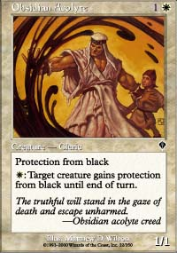
Huge vs. UB
Obsidian Acolyte
With the above said, the Acolyte is now a higher pick in my estimation then is was a week and a half ago. Crucial to the GW deck, I actually found myself taking one over a Razorfoot Griffin while in Dallas. Granted, it was third pack and I had 3 2/2 Flyers for 4, but it's of the utmost importance that you get one of these. A 4th - 6th pick.
Protective Sphere
A number of people told me that, while it wasn't main deck worthy, they felt the Sphere was better then the ranking of 15th pick caliber I gave it. The basic feeling is that in the mirror match, the Sphere can be a decent sideboard card. Don't pick it early, but take it over the Phantasmal Terrains.
Savage Offensive
I still haven't tried this card out, but since Zvi's article last week, a number of players I spoke to had tried it and found it to be as poor as they first thought. I said this card's stock was going up, but I doubt I'll want it in my deck.
Traveler's Cloak
Simply, this is a great sideboard card for a deck that tries to lock the ground down. While you don't want it against UB, you will have times where you want to play it.
Viashino Grappler , Firescreamer , Urborg Phantom While none of these creatures are great by any means, they are all useable in black decks where just having something to attack with is more important then having solid creatures. Don't draft them too high, but if you need creatures in a spell heavy deck, they'll attack for you.

